Created a new Android project in Android Studio and named it "My Water Tracker."

Added the necessary permissions to the AndroidManifest.xml file for the foreground service.

I created a new Kotlin class named WaterTrackerService to handle the water tracking functionality.

Inside the WaterTrackerService class, I defined variables to track the water level and constants for notification ID and intent data key.

I created a notification channel using the NotificationChannel class to support notifications in Android Oreo (API level 26) and above.

I implemented the showNotification() function to display the water level in a notification.

Started the foreground service in the startForegroundService() function by creating a notification and calling startForeground().

I implemented the updateWaterLevel() function to update the water level and call showNotification() to reflect the changes in the notification.

I created a handler and runnable to decrease the water level periodically in the onCreate() method.

I handled the addition of fluids from outside the service by implementing the handleFluidAddition() function.

I overrode the onStartCommand() method to handle the service start command and call handleFluidAddition() if there's an intent.

I overrode the onDestroy() method to remove callbacks and clean up resources when the service is destroyed.

I registered the WaterTrackerService in the AndroidManifest.xml file.

In the MainActivity class, I started the WaterTrackerService in the onCreate() method using startForegroundService().

I added a button to the main activity layout to allow users to manually add water.

I implemented a button click listener to handle button clicks and send an intent to the WaterTrackerService with the water amount added.

MainActivity.kt

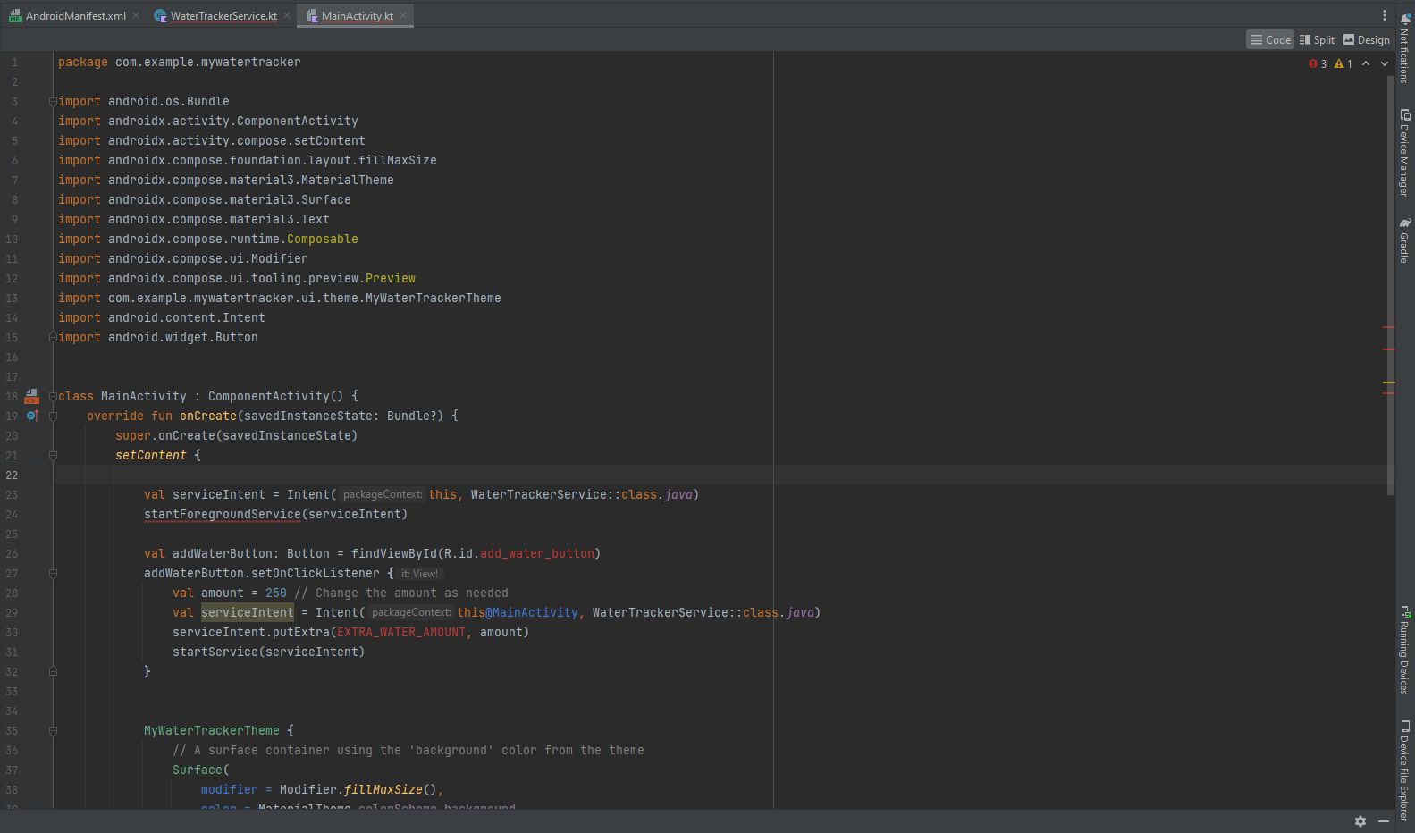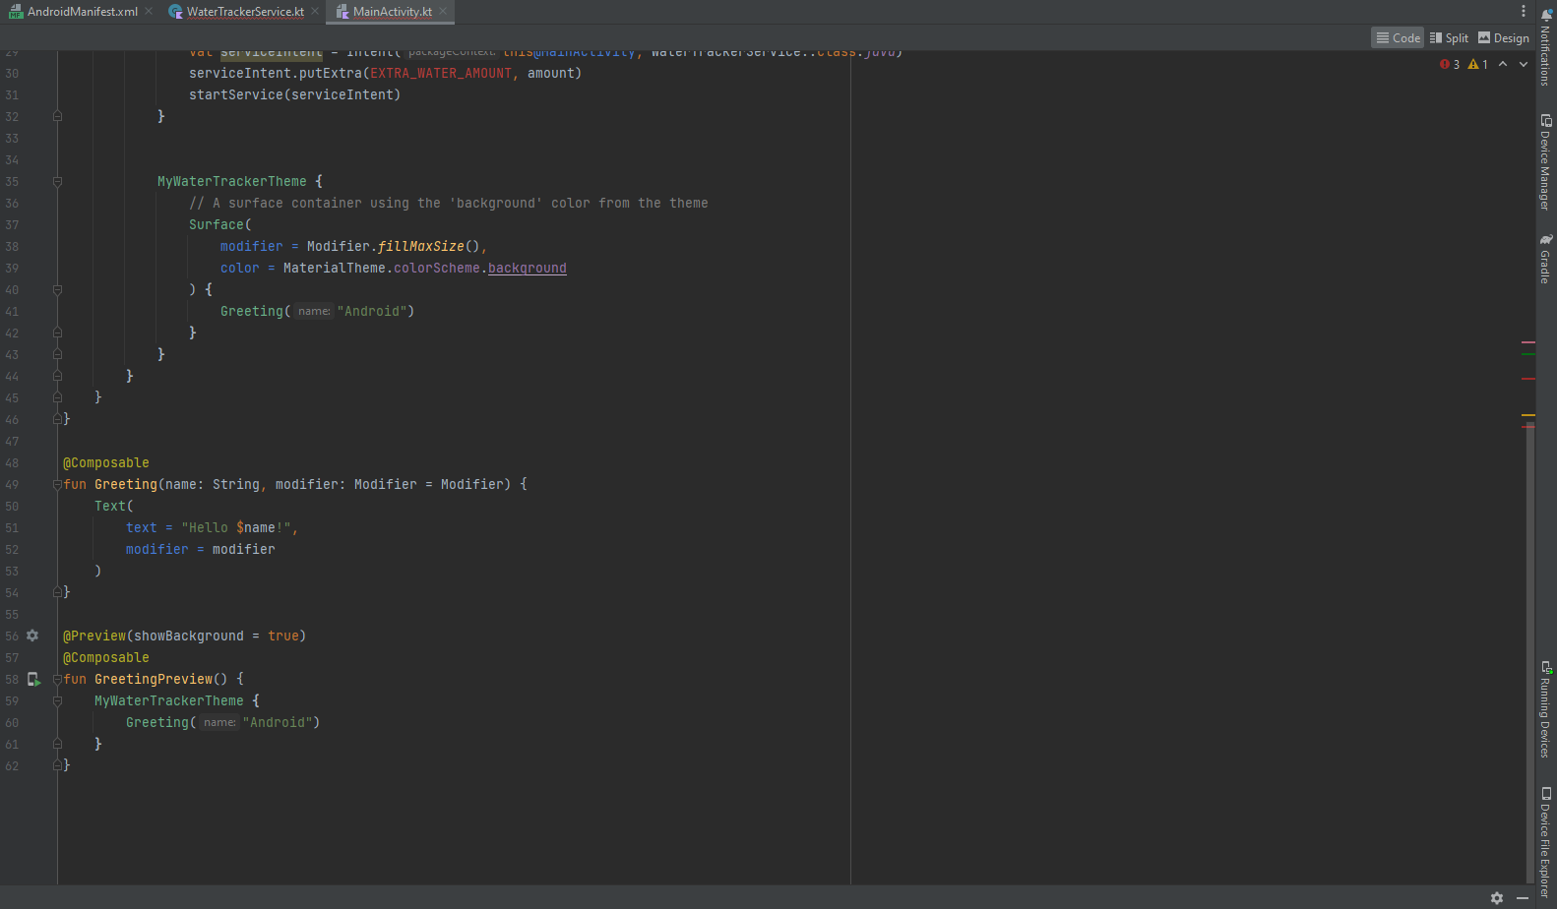

WaterTrackerService

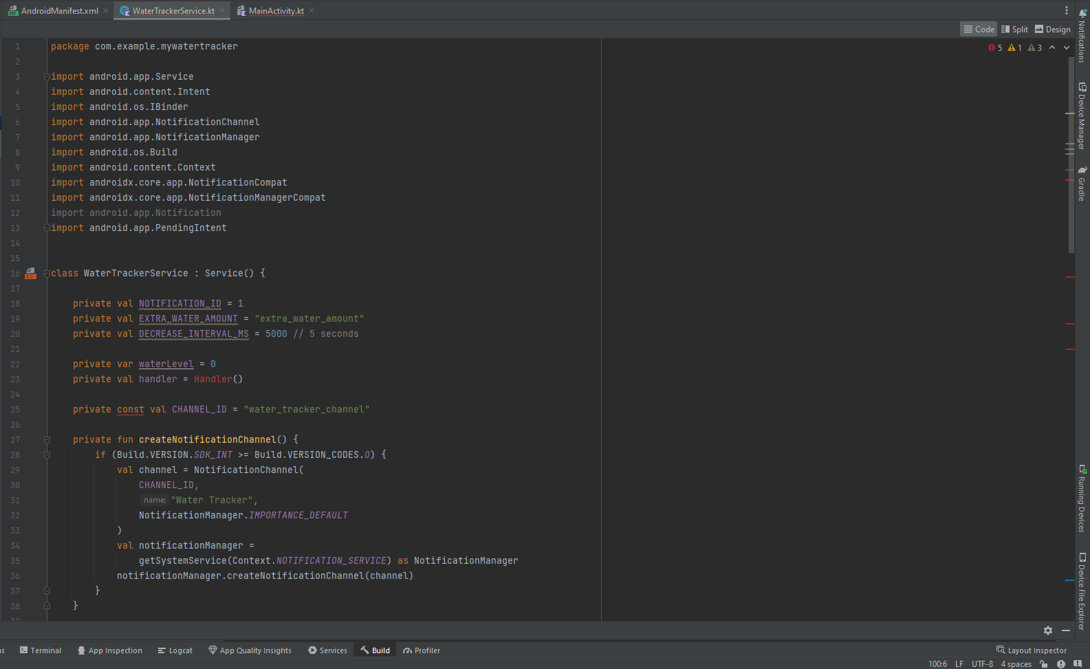

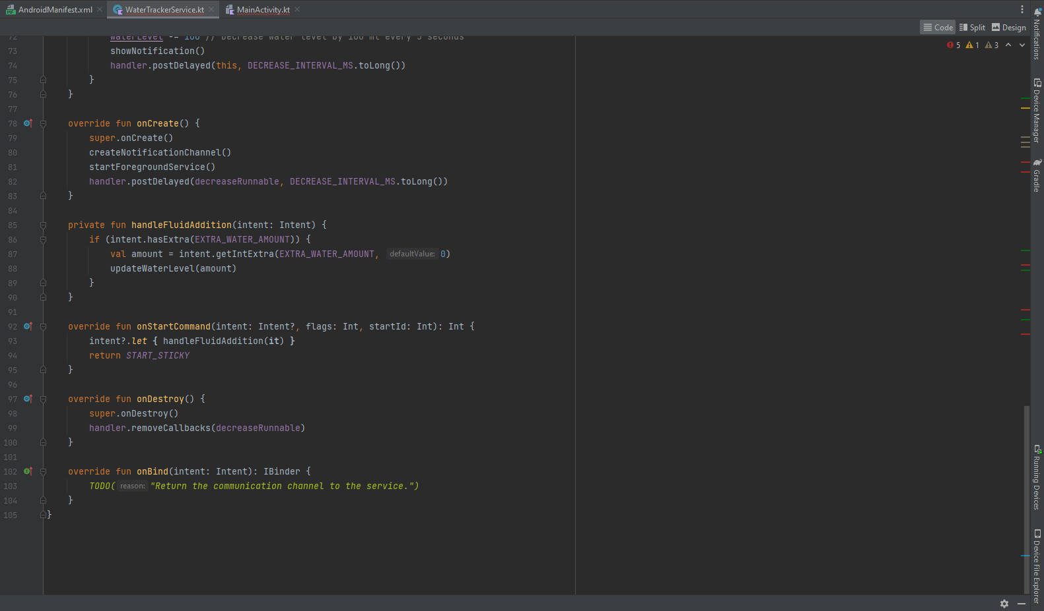



AndroidManifest

